# Load Data into a Relational Data Warehouse

In this exercise, you’re going to load data into a dedicated SQL Pool.

This exercise should take approximately ****30**** minutes to complete.

## Before you start

You’ll need an [Azure subscription](https://azure.microsoft.com/free) in which you have administrative-level access.

## Provision an Azure Synapse Analytics workspace

1. In the PowerShell pane, enter the following commands to clone this repository:

rm -r dp-203 -f

git clone https://github.com/MicrosoftLearning/dp-203-azure-data-engineer dp-203

1. After the repository has been cloned, enter the following commands to change to the folder for this exercise, and run the ****setup.ps1**** script it contains:

cd dp-203/Allfiles/labs/09

./setup.ps1

## Prepare to load data

1. After the script has completed, in the Azure portal, go to the ****dp203-**xxxxxxx** resource group that it created, and select your Synapse workspace.
2. In the ****Overview page**** for your Synapse Workspace, in the ****Open Synapse Studio**** card, select ****Open**** to open Synapse Studio in a new browser tab; signing in if prompted.
3. On the left side of Synapse Studio, use the ›› icon to expand the menu - revealing the different pages within Synapse Studio that you’ll use to manage resources and perform data analytics tasks.
4. On the ****Manage**** page, on the ****SQL pools**** tab, select the row for the ****sql**xxxxxxx** dedicated SQL pool, which hosts the data warehouse for this exercise, and use its ****▷**** icon to start it; confirming that you want to resume it when prompted.

Resuming the pool can take a few minutes. You can use the ****↻ Refresh**** button to check its status periodically. The status will show as ****Online**** when it’s ready. While you’re waiting, proceed with the steps below to view the data files you will load.

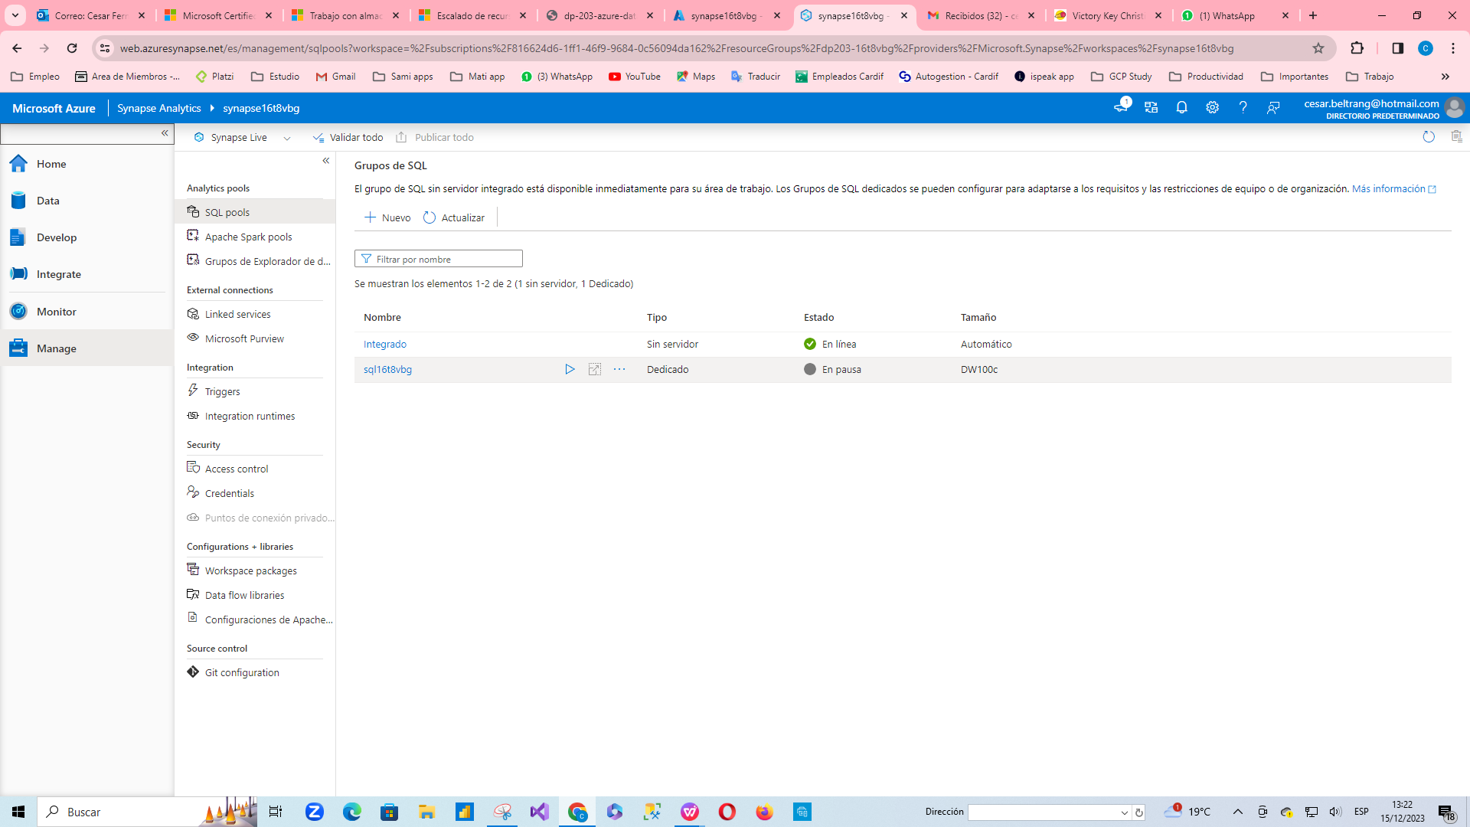

1. On the ****Data**** page, view the ****Linked**** tab and verify that your workspace includes a link to your Azure Data Lake Storage Gen2 storage account, which should have a name similar to ****synapsexxxxxxx (Primary - datalakexxxxxxx)****.
2. Expand your storage account and verify that it contains a file system container named ****files (primary)****.
3. Select the files container, and note that it contains a folder named ****data****. This folder contains the data files you’re going to load into the data warehouse.
4. Open the ****data**** folder and observe that it contains .csv files of customer and product data.

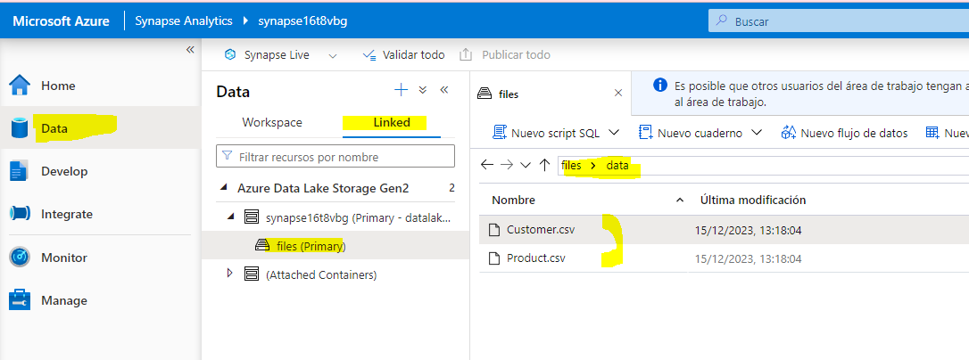

1. Right-click any of the files and select ****Preview**** to see the data it contains. Note the files contain a header row, so you can select the option to display column headers.

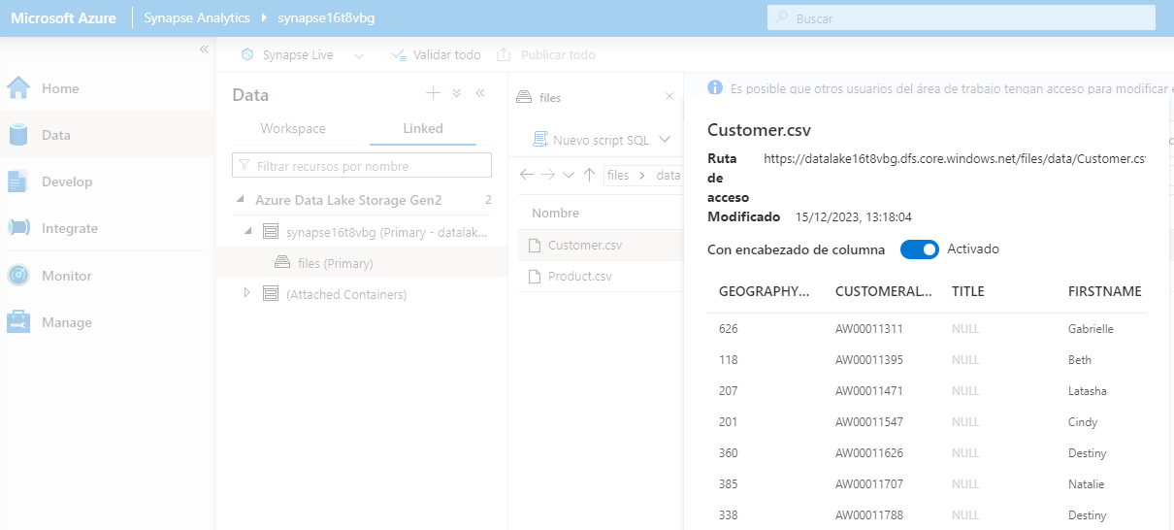

1. Return to the ****Manage**** page and verify that your dedicated SQL pool is online.

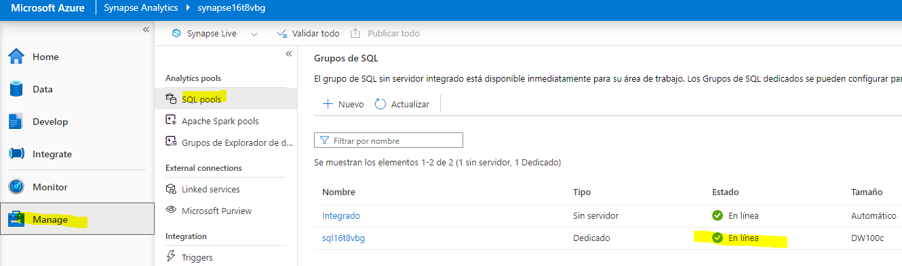

## Load data warehouse tables

Let’s look at some SQL Based approaches to loading data into the Data Warehouse.

1. On the ****Data**** page, select the ****workspace**** tab.
2. Expand ****SQL Database**** and select your ****sql**xxxxxxx** database. Then in its ****…**** menu, select ****New SQL Script**** > ****Empty Script****.

You now have a blank SQL page, which is connected to the instance for the following exercises. You will use this script to explore several SQL techniques that you can use to load data.

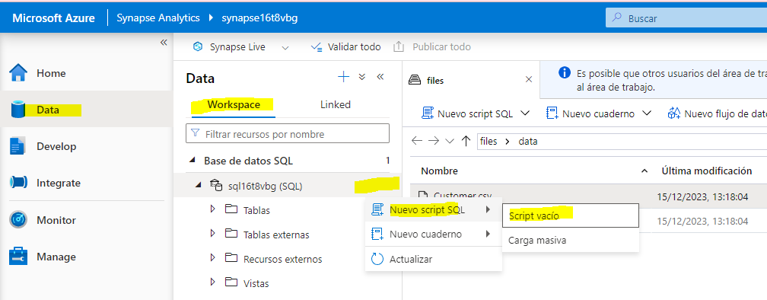

### Load data from a data lake by using the COPY statement

1. In your SQL script, enter the following code into the window.

SELECT COUNT(1)

FROM dbo.StageProduct

1. On the toolbar, use the ****▷ Run**** button to run the SQL code and confirm that there are ****0**** rows currently in the ****StageProduct**** table.

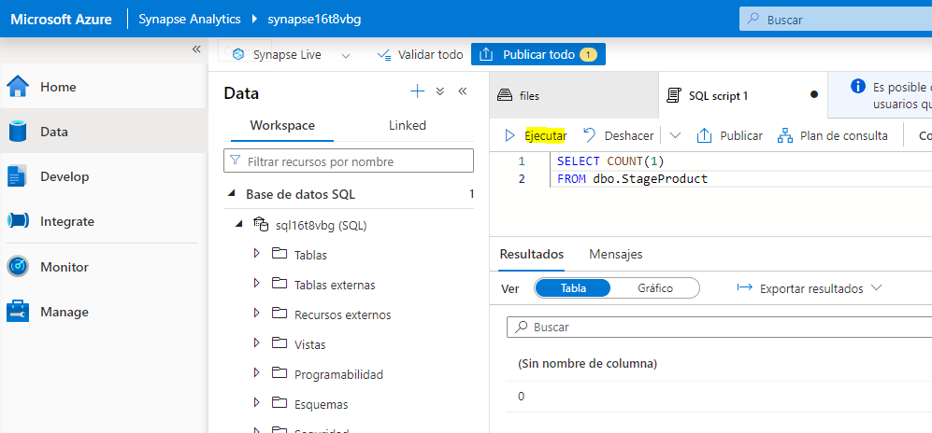

1. Replace the code with the following COPY statement (changing ****datalake**xxxxxx** to the name of your data lake):

COPY INTO dbo.StageProduct

(ProductID, ProductName, ProductCategory, Color, Size, ListPrice, Discontinued)

FROM 'https://datalakexxxxxx.blob.core.windows.net/files/data/Product.csv'

WITH

(

FILE_TYPE = 'CSV',

MAXERRORS = 0,

IDENTITY_INSERT = 'OFF',

FIRSTROW = 2 --Skip header row

);

SELECT COUNT(1)

FROM dbo.StageProduct

1. Run the script and review the results. 11 rows should have been loaded into the ****StageProduct**** table.

Now let’s use the same technique to load another table, this time logging any errors that might occur.

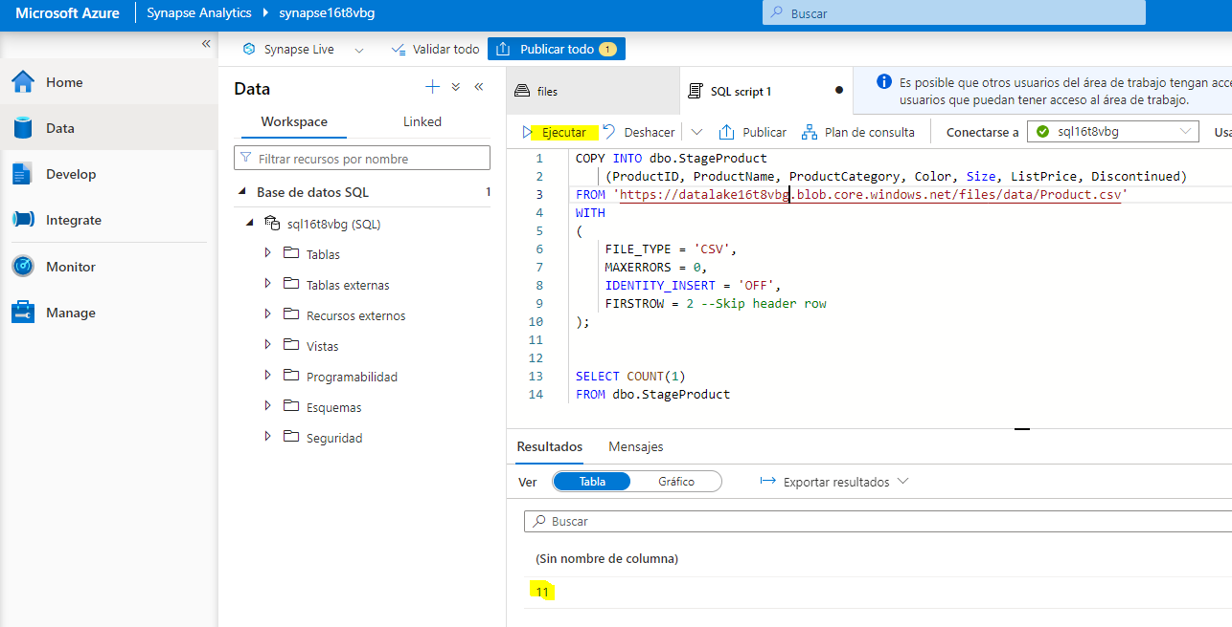

1. Replace the SQL code in the script pane with the following code, changing ****datalake**xxxxxx** to the name of your data lake in both the FROM and the ERRORFILE clauses:

COPY INTO dbo.StageCustomer

(GeographyKey, CustomerAlternateKey, Title, FirstName, MiddleName, LastName, NameStyle, BirthDate,

MaritalStatus, Suffix, Gender, EmailAddress, YearlyIncome, TotalChildren, NumberChildrenAtHome, EnglishEducation,

SpanishEducation, FrenchEducation, EnglishOccupation, SpanishOccupation, FrenchOccupation, HouseOwnerFlag,

NumberCarsOwned, AddressLine1, AddressLine2, Phone, DateFirstPurchase, CommuteDistance)

FROM 'https://datalakexxxxxx.dfs.core.windows.net/files/data/Customer.csv'

WITH

(

FILE_TYPE = 'CSV'

,MAXERRORS = 5

,FIRSTROW = 2 -- skip header row

,ERRORFILE = 'https://datalakexxxxxx.dfs.core.windows.net/files/'

);

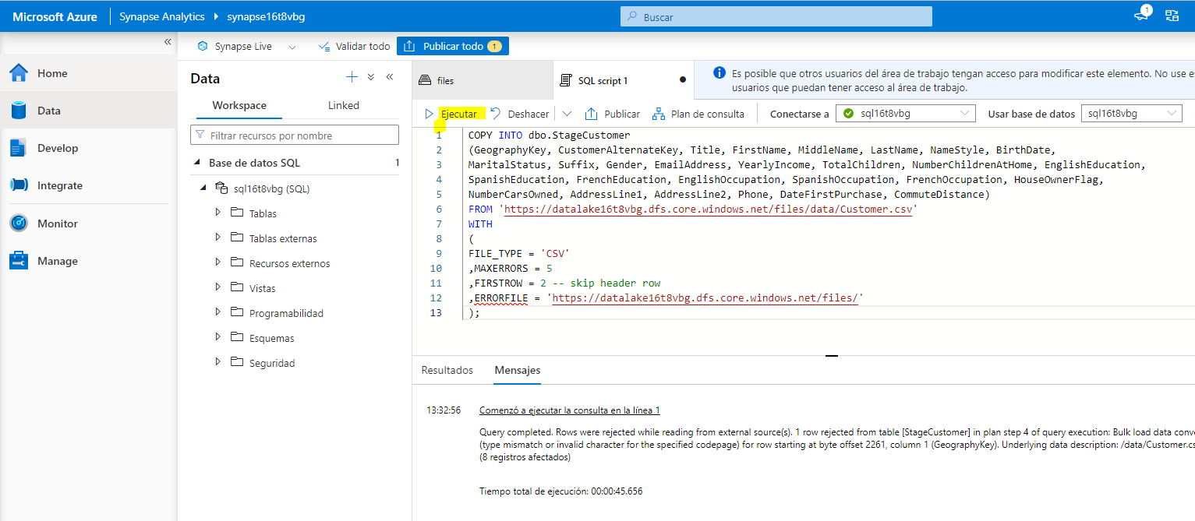

1. Run the script and review the resulting message. The source file contains a row with invalid data, so one row is rejected. The code above specifies a maximum of ****5**** errors, so a single error should not have prevented the valid rows from being loaded. You can view the rows that have been loaded by running the following query.

SELECT *

FROM dbo.StageCustomer

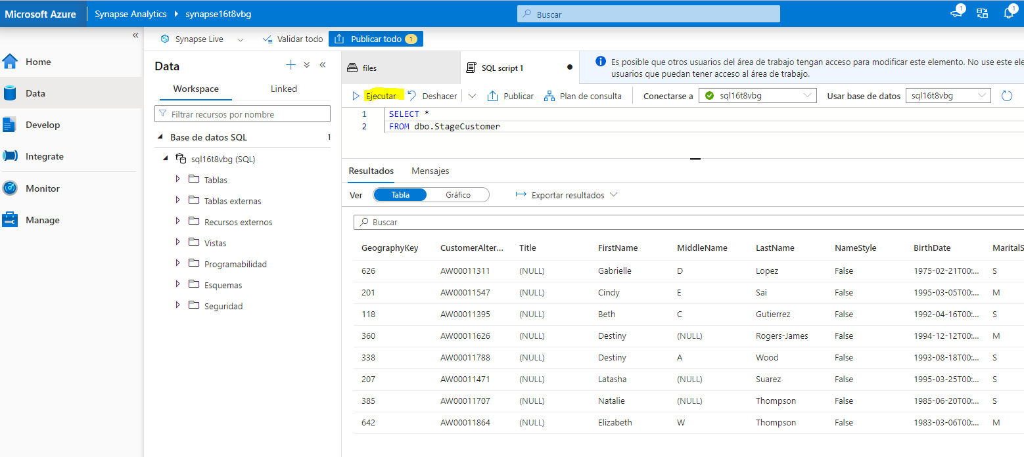

1. On the ****files**** tab, view the root folder of your data lake and verify that a new folder named ****_rejectedrows**** has been created (if you don’t see this folder, in the ****More**** menu, select ****Refresh**** to refresh the view).

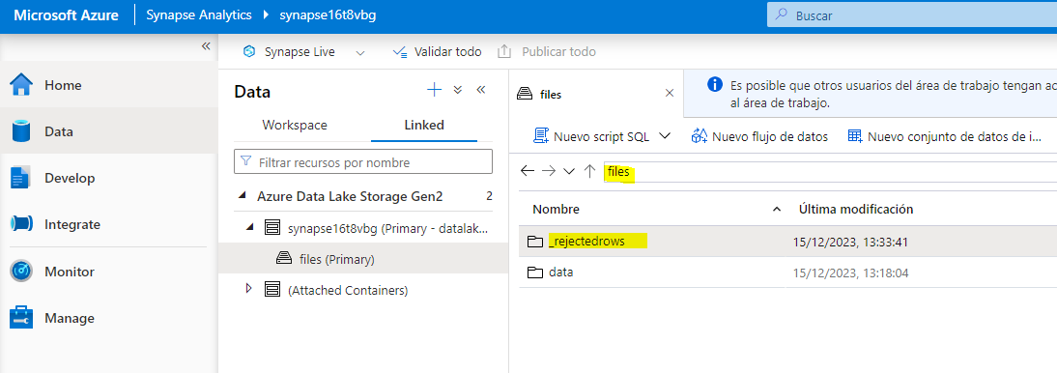

1. Open the ****_rejectedrows**** folder and the date and time specific subfolder it contains, and note that files with names similar to **QID123_1_2**.Error.Txt**** and **QID123_1_2**.Row.Txt**** have been created. You can right-click each of these files and select ****Preview**** to see details of the error and the row that was rejected.

The use of staging tables enables you to validate or transform data before moving or using it to append to or upsert into any existing dimension tables. The COPY statement provides a simple but high-performance technique that you can use to easily load data from files in a data lake into staging tables, and as you’ve seen, identify and redirect invalid rows.

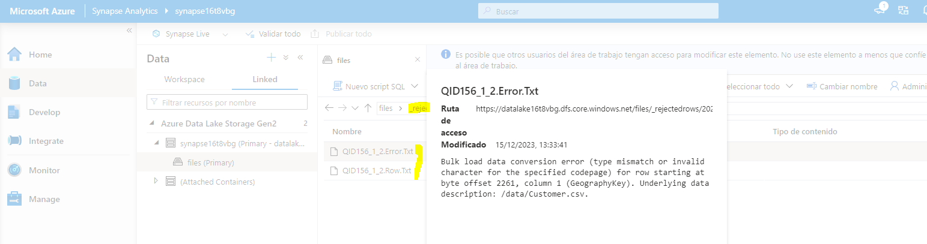

### Use a CREATE TABLE AS (CTAS) statement

1. Return to the script pane, and replace the code it contains with the following code:

CREATE TABLE dbo.DimProduct

WITH

(

DISTRIBUTION = HASH(ProductAltKey),

CLUSTERED COLUMNSTORE INDEX

)

AS

SELECT ROW_NUMBER() OVER(ORDER BY ProductID) AS ProductKey,

ProductID AS ProductAltKey,

ProductName,

ProductCategory,

Color,

Size,

ListPrice,

Discontinued

FROM dbo.StageProduct;

1. Run the script, which creates a new table named ****DimProduct**** from the staged product data that uses ****ProductAltKey**** as its hash distribution key and has a clustered columnstore index.

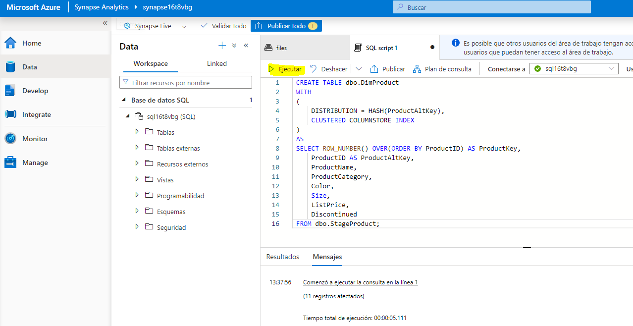

1. Use the following query to view the contents of the new ****DimProduct**** table:

SELECT ProductKey,

ProductAltKey,

ProductName,

ProductCategory,

Color,

Size,

ListPrice,

Discontinued

FROM dbo.DimProduct;

The CREATE TABLE AS SELECT (CTAS) expression has various uses, which include:

* Redistributing the hash key of a table to align with other tables for better query performance.
* Assigning a surrogate key to a staging table based upon existing values after performing a delta analysis.
* Creating aggregate tables quickly for report purposes.

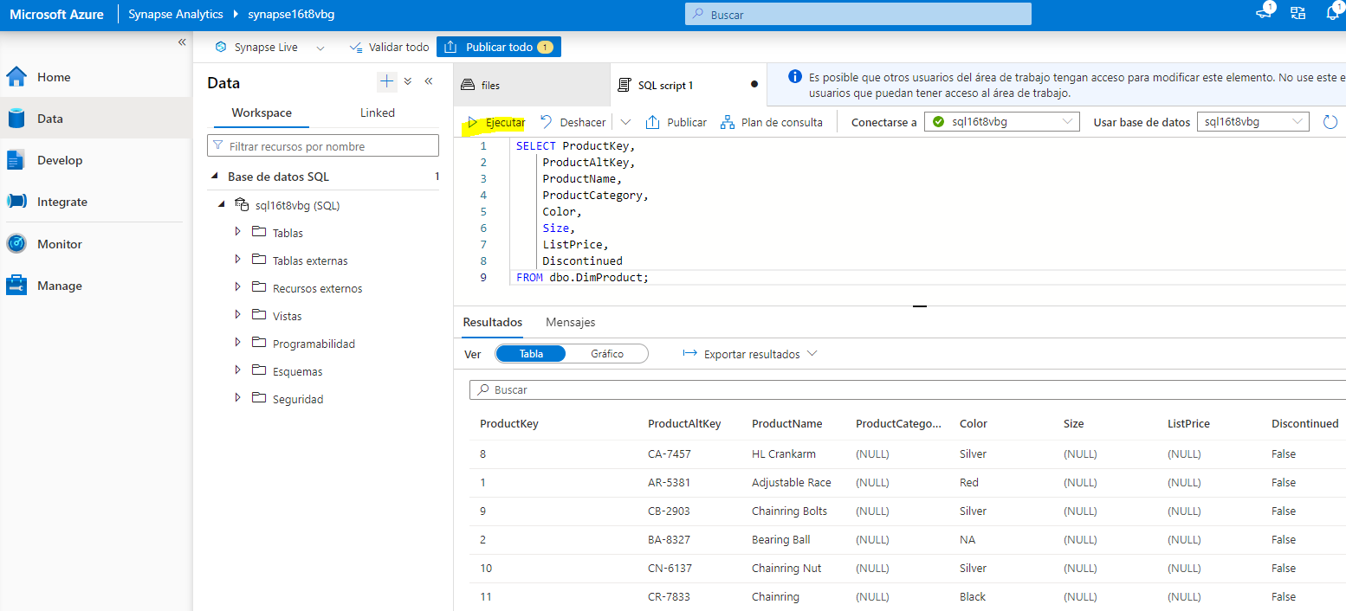

### Combine INSERT and UPDATE statements to load a slowly changing dimension table

The ****DimCustomer**** table supports type 1 and type 2 slowly changing dimensions (SCDs), where type 1 changes result in an in-place update to an existing row, and type 2 changes result in a new row to indicate the latest version of a particular dimension entity instance. Loading this table requires a combination of INSERT statements (to load new customers) and UPDATE statements (to apply type 1 or type 2 changes).

1. In the query pane, replace the existing SQL code with the following code:

INSERT INTO dbo.DimCustomer ([GeographyKey],[CustomerAlternateKey],[Title],[FirstName],[MiddleName],[LastName],[NameStyle],[BirthDate],[MaritalStatus],

[Suffix],[Gender],[EmailAddress],[YearlyIncome],[TotalChildren],[NumberChildrenAtHome],[EnglishEducation],[SpanishEducation],[FrenchEducation],

[EnglishOccupation],[SpanishOccupation],[FrenchOccupation],[HouseOwnerFlag],[NumberCarsOwned],[AddressLine1],[AddressLine2],[Phone],

[DateFirstPurchase],[CommuteDistance])

SELECT *

FROM dbo.StageCustomer AS stg

WHERE NOT EXISTS

(SELECT * FROM dbo.DimCustomer AS dim

WHERE dim.CustomerAlternateKey = stg.CustomerAlternateKey);

-- Type 1 updates (change name, email, or phone in place)

UPDATE dbo.DimCustomer

SET LastName = stg.LastName,

EmailAddress = stg.EmailAddress,

Phone = stg.Phone

FROM DimCustomer dim inner join StageCustomer stg

ON dim.CustomerAlternateKey = stg.CustomerAlternateKey

WHERE dim.LastName <> stg.LastName OR dim.EmailAddress <> stg.EmailAddress OR dim.Phone <> stg.Phone

-- Type 2 updates (address changes triggers new entry)

INSERT INTO dbo.DimCustomer

SELECT stg.GeographyKey,stg.CustomerAlternateKey,stg.Title,stg.FirstName,stg.MiddleName,stg.LastName,stg.NameStyle,stg.BirthDate,stg.MaritalStatus,

stg.Suffix,stg.Gender,stg.EmailAddress,stg.YearlyIncome,stg.TotalChildren,stg.NumberChildrenAtHome,stg.EnglishEducation,stg.SpanishEducation,stg.FrenchEducation,

stg.EnglishOccupation,stg.SpanishOccupation,stg.FrenchOccupation,stg.HouseOwnerFlag,stg.NumberCarsOwned,stg.AddressLine1,stg.AddressLine2,stg.Phone,

stg.DateFirstPurchase,stg.CommuteDistance

FROM dbo.StageCustomer AS stg

JOIN dbo.DimCustomer AS dim

ON stg.CustomerAlternateKey = dim.CustomerAlternateKey

AND stg.AddressLine1 <> dim.AddressLine1;

1. Run the script and review the output.

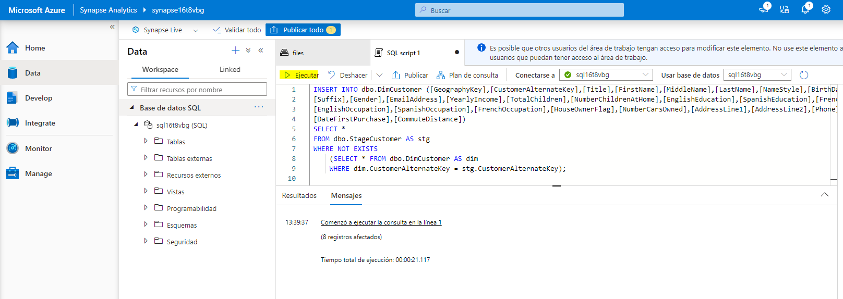

## Perform post-load optimization

After loading new data into the data warehouse, it’s recommended to rebuild the table indexes and update statistics on commonly queried columns.

1. Replace the code in the script pane with the following code:

ALTER INDEX ALL ON dbo.DimProduct REBUILD;

1. Run the script to rebuild the indexes on the ****DimProduct**** table.

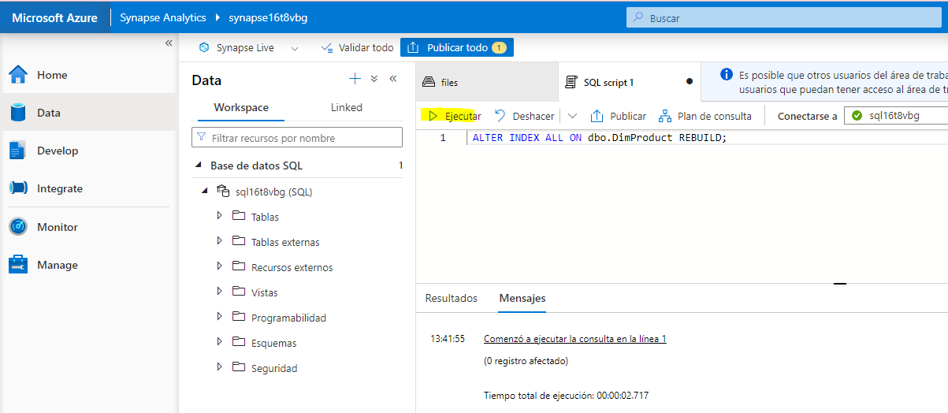

1. Replace the code in the script pane with the following code:

CREATE STATISTICS customergeo_stats

ON dbo.DimCustomer (GeographyKey);

1. Run the script to create or update statistics on the ****GeographyKey**** column of the ****DimCustomer**** table.

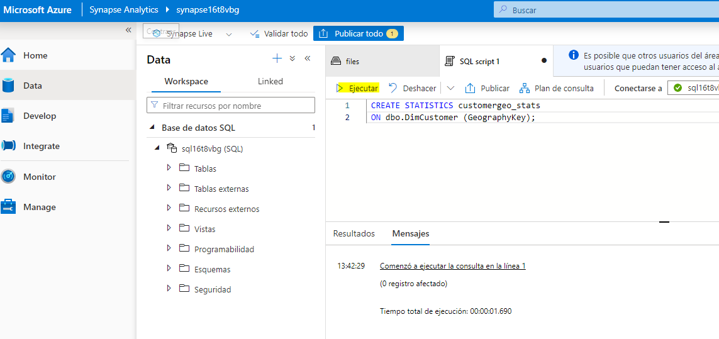

## Delete Azure resources

If you’ve finished exploring Azure Synapse Analytics, you should delete the resources you’ve created to avoid unnecessary Azure costs.

1. Close the Synapse Studio browser tab and return to the Azure portal.
2. On the Azure portal, on the ****Home**** page, select ****Resource groups****.
3. Select the ****dp203-**xxxxxxx** resource group for your Synapse Analytics workspace (not the managed resource group), and verify that it contains the Synapse workspace, storage account, and Spark pool for your workspace.
4. At the top of the ****Overview**** page for your resource group, select ****Delete resource group****.
5. Enter the ****dp203-**xxxxxxx** resource group name to confirm you want to delete it, and select ****Delete****.

After a few minutes, your Azure Synapse workspace resource group and the managed workspace resource group associated with it will be deleted.

